Simple Lesson Documentation

Version 2.0

Table of Contents
Simple Lesson Documentation 1
Version 2.0 1
Introduction 2
Upgrading from Version 1 2
Simple Lesson Features 2
Installing Simple Lesson 3
Configuration 3
Adding a Simple Lesson to a Course 3
Moodle standard Activity Settings 5
Manage Questions 5
he Page Management Console 8
Preview mode 9
Attempt mode 10
Essay Questions 11
Reports 12
Learning Strategies 13
Troubleshooting 14
Thank you 14

Introduction
Simple Lesson is a third-party plugin for Moodle that can be used for content presentation and assessment. It allows multiple pages of content to be navigated and the adding of a question from the Question Bank to any page.
There is reporting for teachers and students on both question responses and lesson attempts. Simple Lesson also implements GDPR requirements.
Designed for Moodle 4.

Upgrading from Version 1
Version 2 uses some new features of Moodle 4, in particular the updated Question Bank. The update process would be:
- Update your Moodle installation to Moodle version 4.
- Upgrade your Simple Lesson plugin to Version 2.0
If you upgrade Simple Lesson Version1 in a Moodle 3.5 to 3.11 it will produce some errors.

Simple Lesson Features
- Supports adding questions from the question bank
- Behaviours adaptive, immediate and deferred feedback supported
- Essay questions supported (manual grading required)
- Easy to add and then automatically sequence pages
- Consists of multimedia pages with simple hyperlinked navigation
- Summary lesson attempt reports for students and teacher's
- Manual marking of essay questions, updates to the gradebook.
- Implements GDPR privacy requests for reporting and deletion of user data
- Designed for Moodle 4
Simple Lesson has features in common with Book, Lesson and Quiz. It has been designed as a formative assessment tool. For summative assessment Quiz and Lesson have more features such as timing and access restrictions.
Duplicate, Backup and Restore have been implemented but questions will be lost because of the way Moodle Question Categories are implemented across activities and courses. However, once you export and re-import your questions to the new course, they can be added back to the Simplelesson.

Installing Simple Lesson
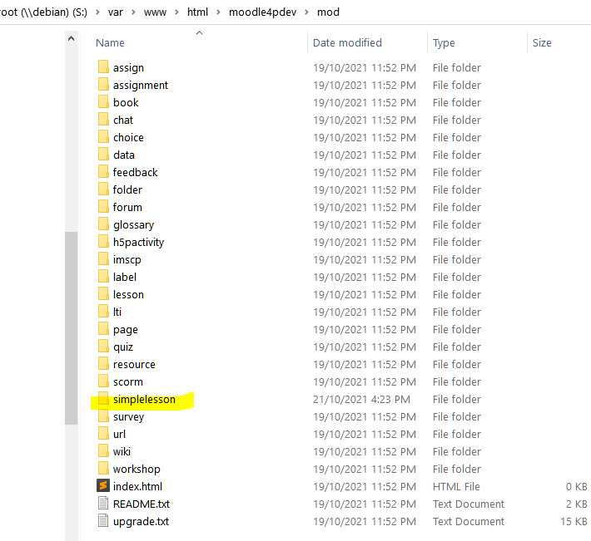
Obtain the code from:
- Github: https://github.com/richardjonesnz/moodle-mod_simplelesson
- Moodle Plugins Directory: https://moodle.org/plugins/mod_simplelesson
And unpack the code into the mod folder of the Moodle root folder.
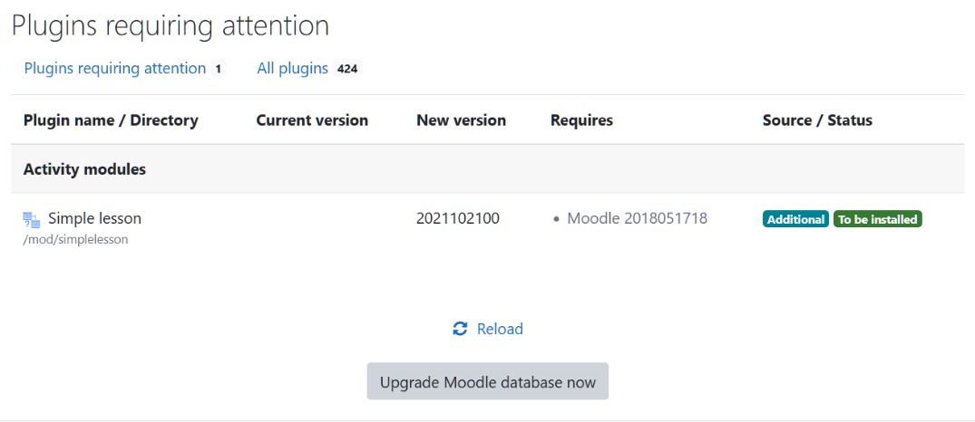
Visit the Administration page to install the plugin.

Configuration
There is only one admin configuration setting, this allows administrators to determine whether teachers can view the reports of students on the lesson attempts:
The settings for the Simple lesson plugin:
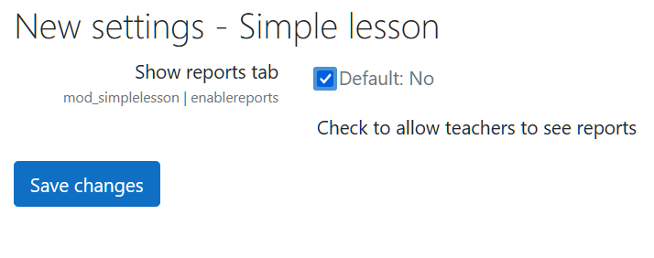

Adding a Simple Lesson to a Course
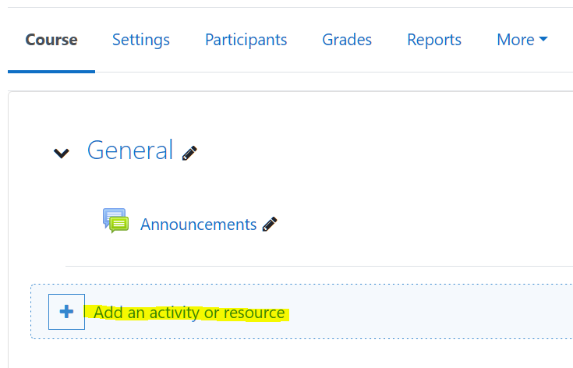
Turn Edit mode on for your course and select the topic/week where you want the Simple Lesson to appear then click Add an activity or resource to view the activity chooser:
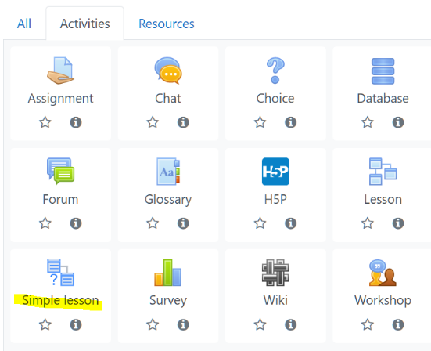

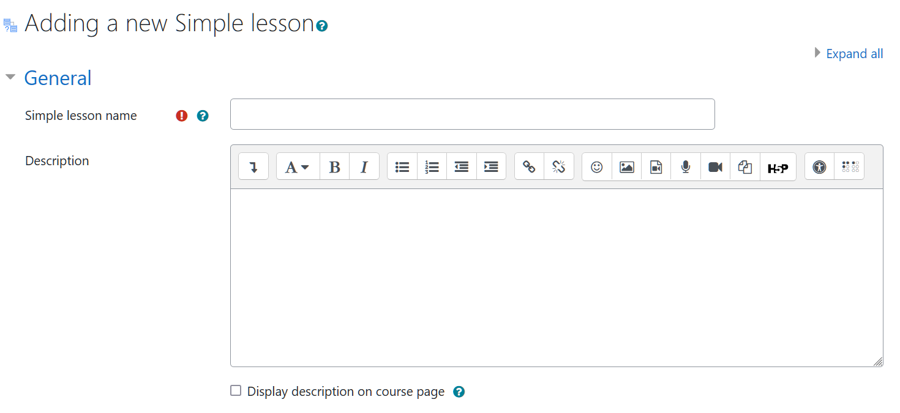
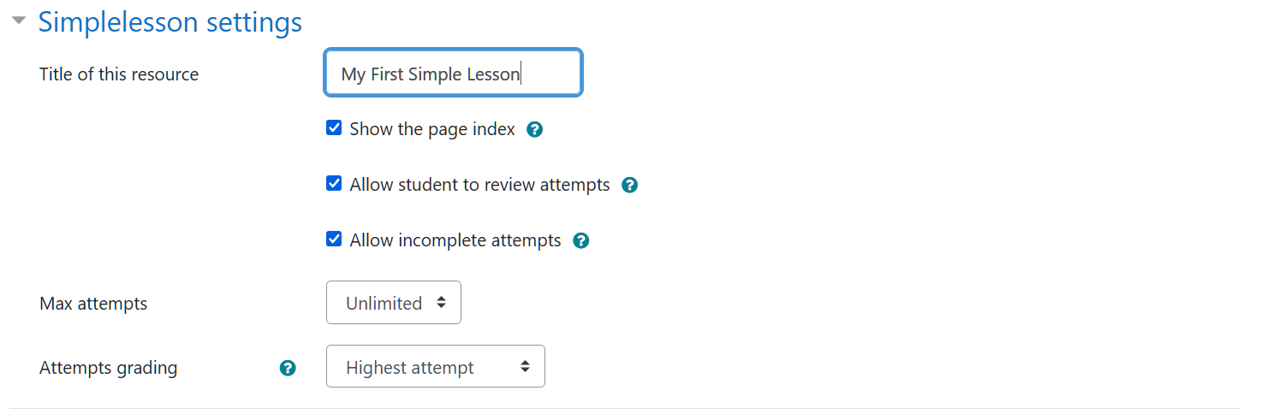

Lesson name
You must give the Simple lesson a name and fill in the description fields as it forms the first page your users will see. The name is the link to the activity as it appears in the course.

Description
Add the description but do not check the box Display description on course page! You can add media such as images or video from a repository.

Title of the resource
This can be different to the lesson name and will appear on the first page.

Page index
The page index is optional and will show on the top right of every content page by default. This can be overridden by themes.

Allow student to review attempts
If this is checked the student can see the review page showing their responses, times and scores.

Allow incomplete attempts
If this is checked, the navigation buttons (home, next, previous) are always available to the student. Otherwise the navigation only appears after an answer has been submitted. The way the question is completed then depends on the Question Behaviour that has been set (more in a moment).

Max attempts
Teachers always have unlimited attempts, but student attempts can be limited if you wish.

Attempts grading
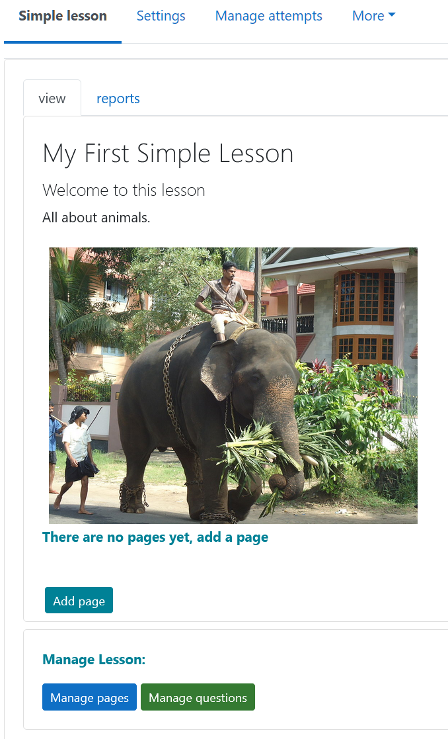
The strategy to be used for grading students (adding grades to the gradebook or updating them as necessary):
• Highest attempt
• Latest attempt
• Average of attempts

Moodle standard Activity Settings
You can select the grading type and Simple Lesson also supports grade re-scaling if required. Activity completion supports requiring a given grade to be achieved.
Other settings are standard Moodle.
Having saved our settings we see the first page of the lesson.
Return to the Settings by using the breadcrumbs above the activity.
You won’t be able to Manage Pages yet (needs at least two pages to work with) but you can add a page or select a question category using Manage questions.

Manage Questions
Users of Simple Lesson Version 1 will be happy to see that selecting questions and categories is much simplified.

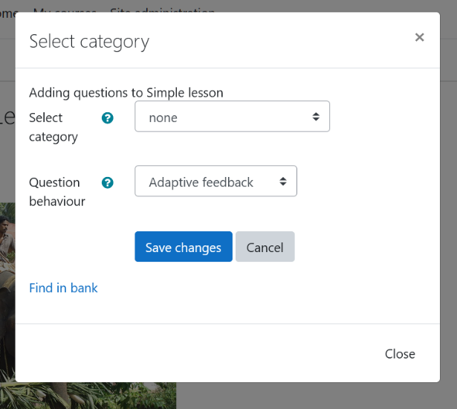
Select category
This will show any Question Banks that are available in this activity, course or other Moodle context and will also depend upon your permissions.
However, if you find you have no questions, select Find in bank to organise and/or create them.

Question behaviour
Currently the 6 most common types of feedback are implemented although more could be used if requested.
Adaptive: They can try the question until they get it completely correct. Each incorrect attempt
reduces the mark (it’s a penalty).
- Adaptive feedback: They can try the question until they get it completely correct. Each incorrect attempt reduces the mark (it’s a penalty).
- Adaptive (no penalty): They can try the question until they get it completely correct. Each incorrect attempt has no effect on the mark.
- Immediate feedback: The participant gets one attempt to check correctness of their response
- Deferred feedback: The score is not revealed to the student and there is a save button. They can have multiple tries.
- Immediate feedback with CBM: CBM or Certainty-Based Marking is when the user is asked to give their answer a certainty (how sure they are it is correct). If they are sure but incorrect they can score below zero!
- Deferred feedback with CBM. The score is not known until the end, this is a tough way to treat your students but it does allow a realistic assessment of understanding.
See: https://docs.moodle.org/311/en/Using_certainty-based_marking.

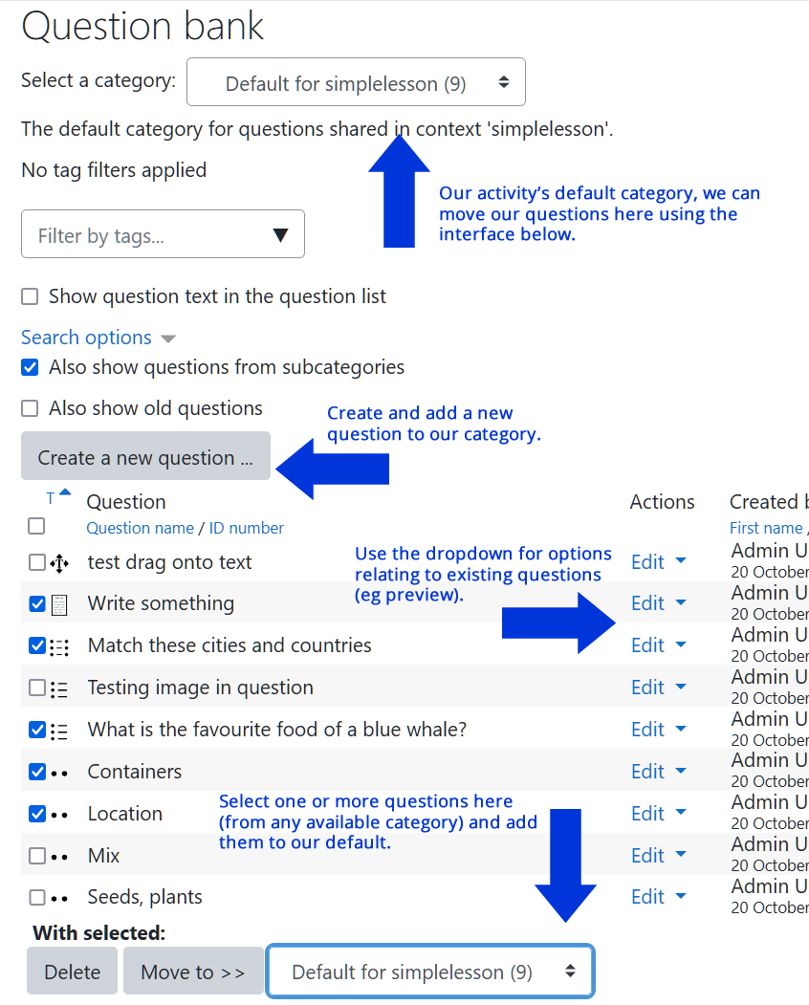
IMPORTANT
Note that for all types of feedback, depending on the setting of the Allow incomplete checkbox, navigation may not appear until the question has been answered (completed).

Find in bank
This is a link to the Question Bank interface.
After using the bank you can navigate back to your course using the breadcrumbs at the top of the page.
Each question that is included in the lesson can be allocated a score. The sum of these is the attempt score.
If any essay questions are included, they must be manually graded to assign a score.

See also: https://docs.moodle.org/311/en/Question_bank or check the documentation for the latest Moodle version when it arrives.

Adding a new page
When you click the Add page link you see the page editor:
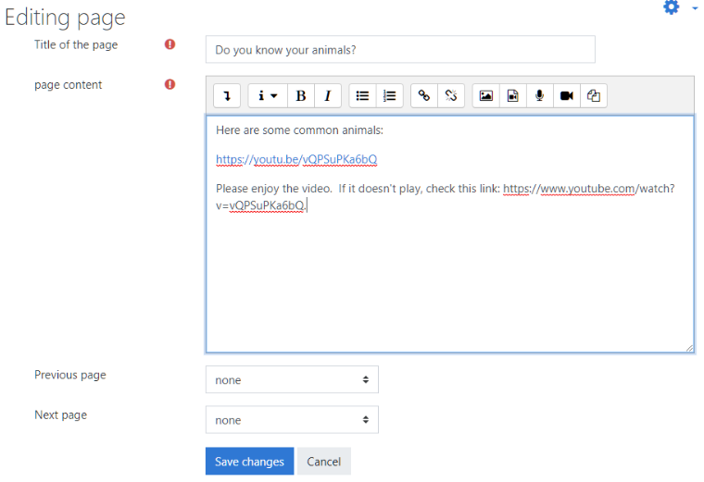
Title and content must be filled in. Content may contain media, such as audio and video as well as images.
There are drop-down lists to link to other pages but it is usually better to just go ahead and add all the pages you need as the links and sequencing can be fixed up easily on the Page Management console.

After save you can see the layout - including the index (if enabled in settings):
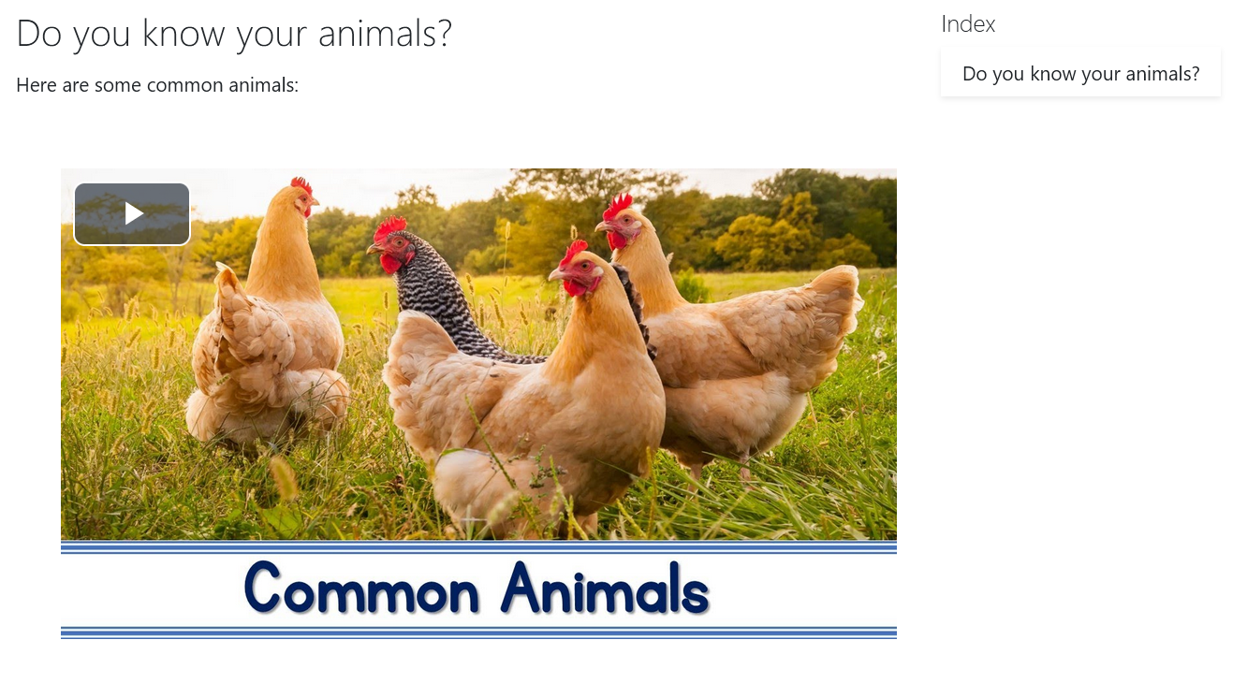
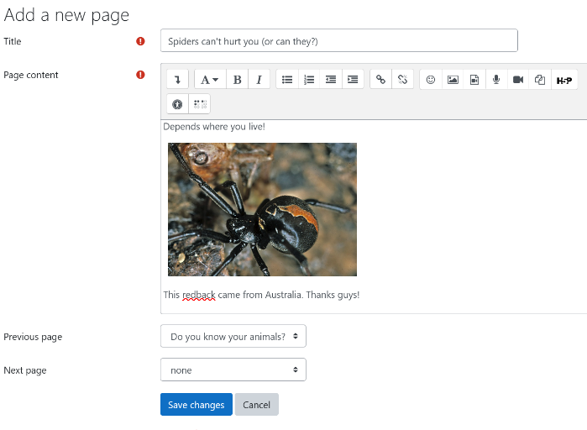
Add more pages (click the preview button to see the Manage pages link):
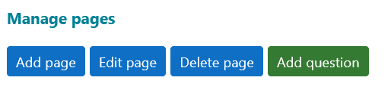

he Page Management Console
The heart of our Simple Lesson activity.
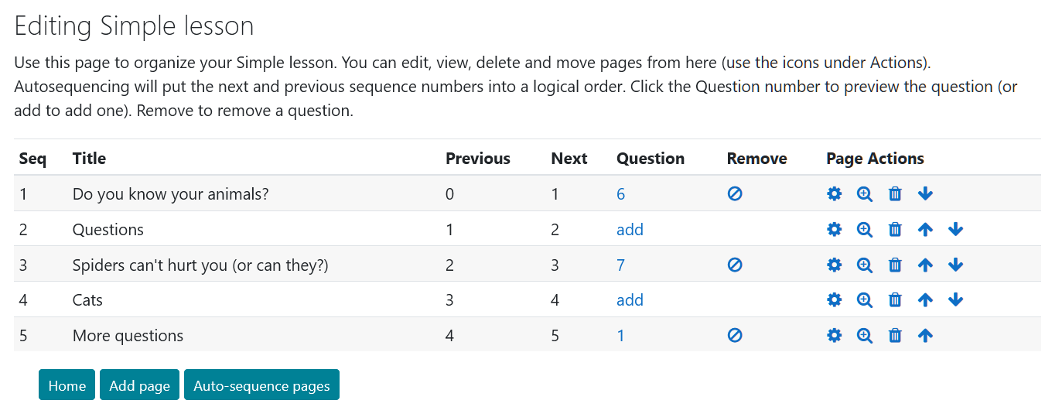
The Page Management link allows you to move your pages around as well as add, edit and delete them. The auto-sequence link sets all the links in the order of pages you have set on this screen. That is, page one will have a next link to page 2, page 2 links next to 3 and previous to 1.
This makes sequencing your pages very easy.
NEW FEATURE! You can now add, delete and preview your questions from here (make sure you have selected a category from the Manage Questions page).
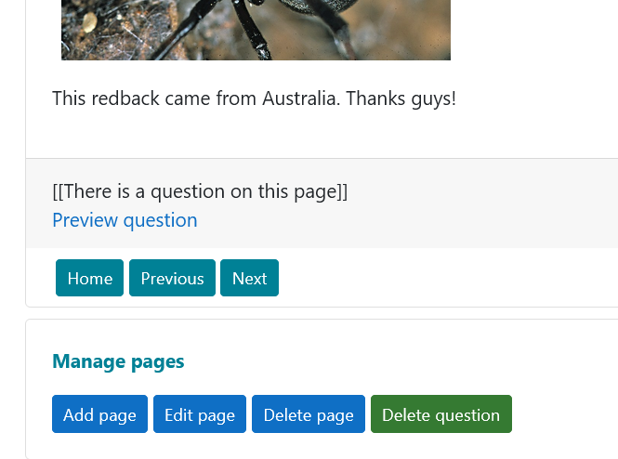
You may also add and delete questions when previewing a page.
Notice that the “placeholder” will let you know that the page has a question and give you a preview link.
If the page has a question you can delete it, if it doesn’t you can add one.
Only one question is permitted per page.
You may also allocate a score for a question when adding to the page:
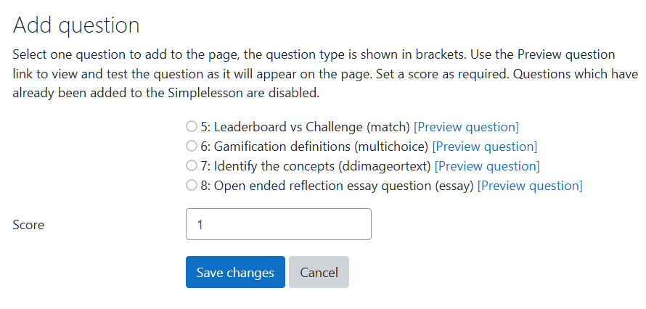
These raw scores will be listed in the answer and attempt tables. When the activity is graded, the overall score for the attempt will be calculated.
If you have selected to grade by score, the attempt score will be scaled up and moved to the grade book.

Preview question
When you preview a question you are taken to the new Question Bank preview page.
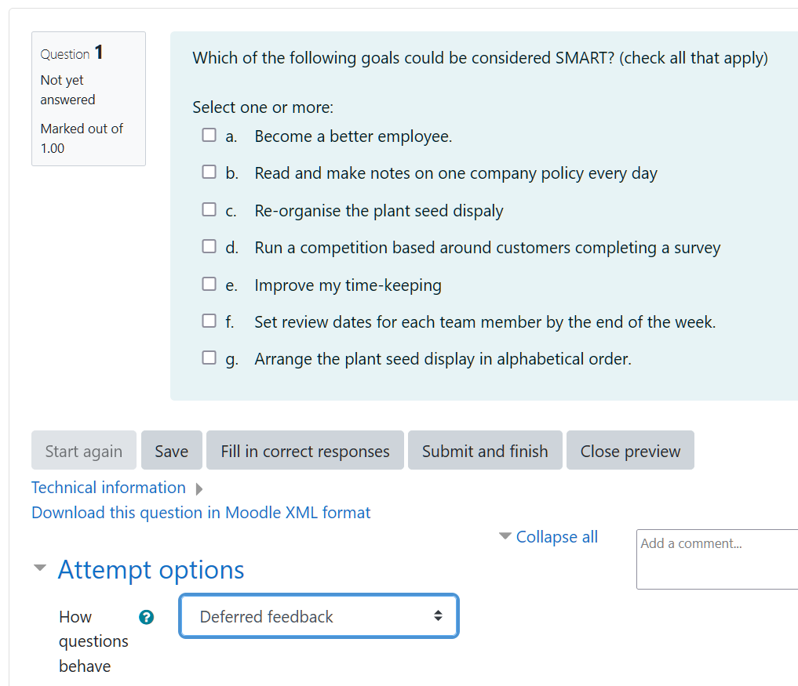
This allows you to check how the question works, verify the answers are correct, check the feedback and see how the question will behave under the different behaviours. Closing the preview returns you to Simple Lesson.

Preview mode
This is your primary page editing and testing mode. In preview mode the page contents can be viewed, but no questions will appear (the placeholder and preview link will show you that there is a question on the page). Navigation is also possible using the index.
If you are a user with Lesson Management capability (editing teacher for example) you will see the Manage pages options too.
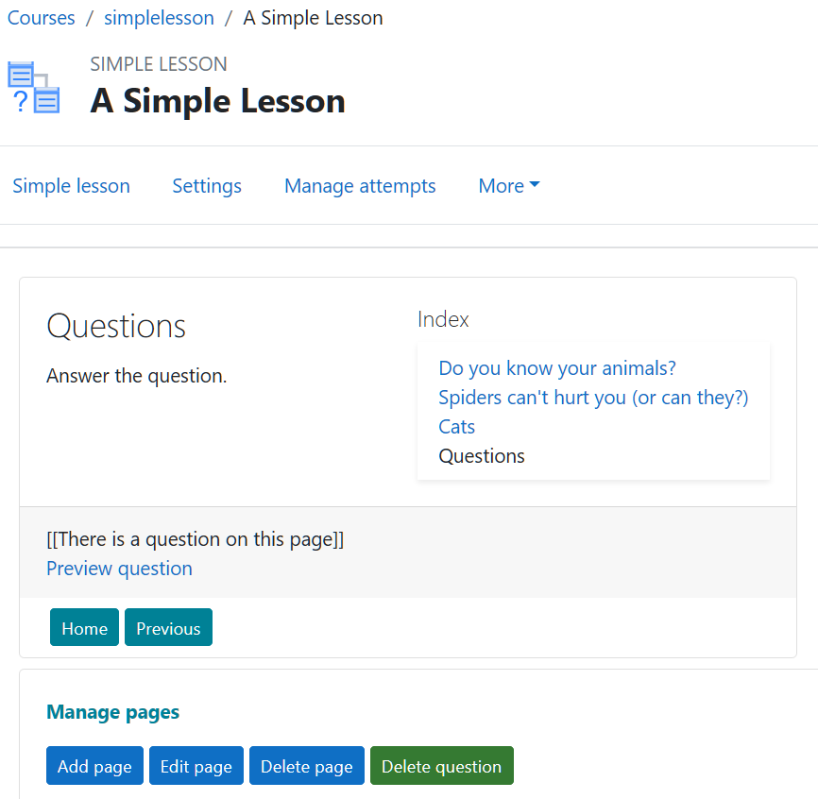

Attempt mode
When a student starts an attempt (assuming they haven’t exceeded the max attempts in settings) they will see the same pages as in Preview mode plus any questions that have been added:
In Attempt mode questions appear more like they would do in a quiz.
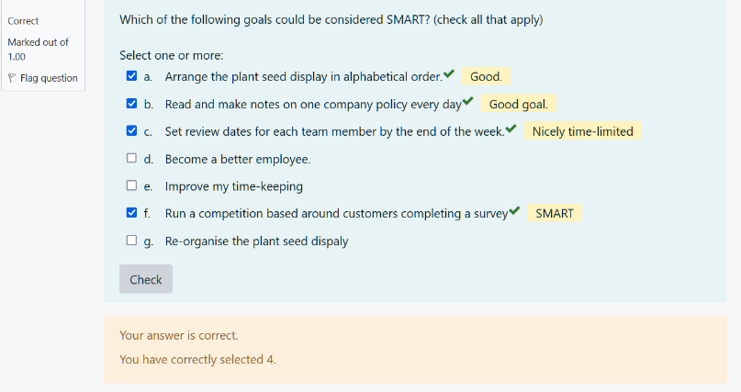
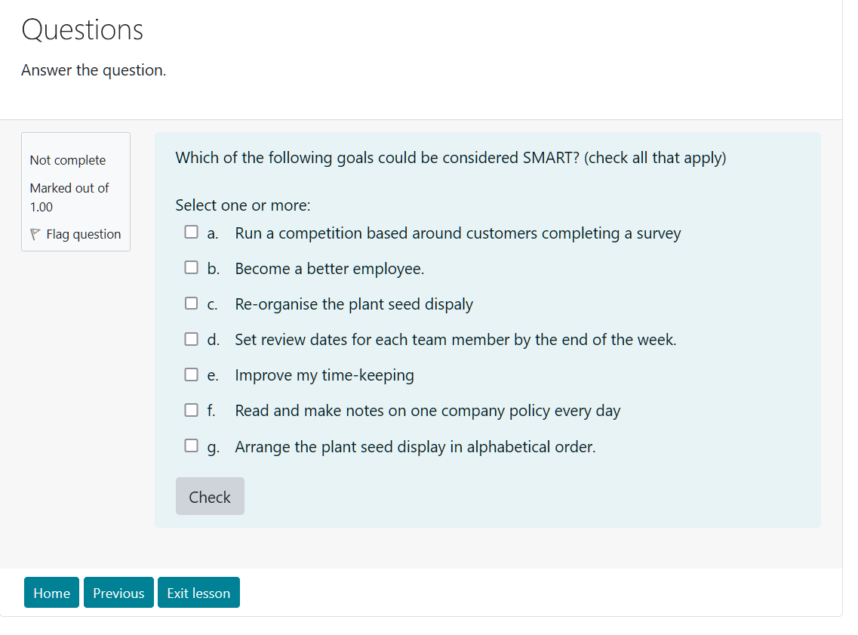
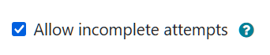
The navigation buttons will be present if Allow incomplete is checked and if there is no question on a page. They will also be visible after a question is answered, whatever feedback method is used.
Depending on the type of feedback selected in settings they may have one or more chances to answer the question.
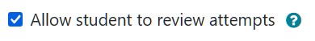
When the student finishes they see a review of their answers if the teacher has permitted review. If they didn’t answer a question it doesn’t appear in the review and the attempt is marked incomplete.
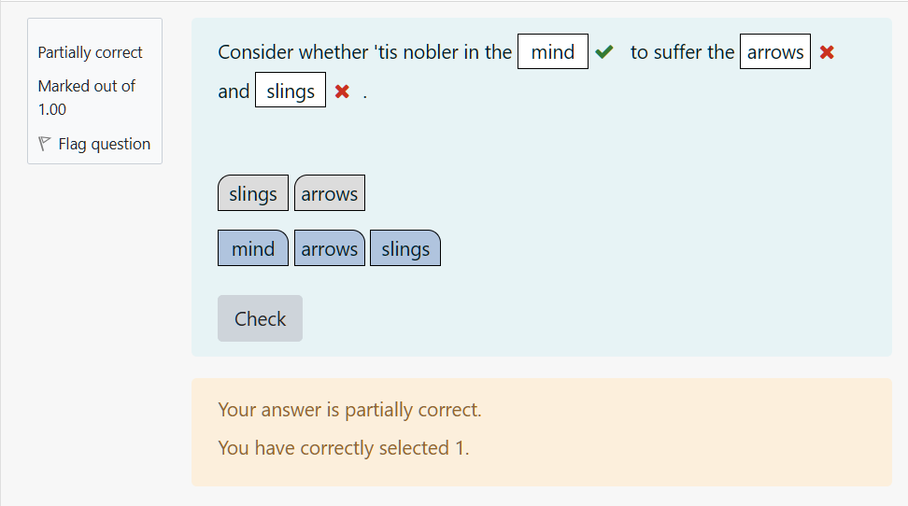
The Page Index does not appear during an attempt.
On the right is an answered question using adaptive feedback, the navigation won’t appear until the answer is correct. This is useful for reinforcing concepts and knowledge.
For more formal types of assessment, you may want to select Deferred Feedback.

Attempt Summary
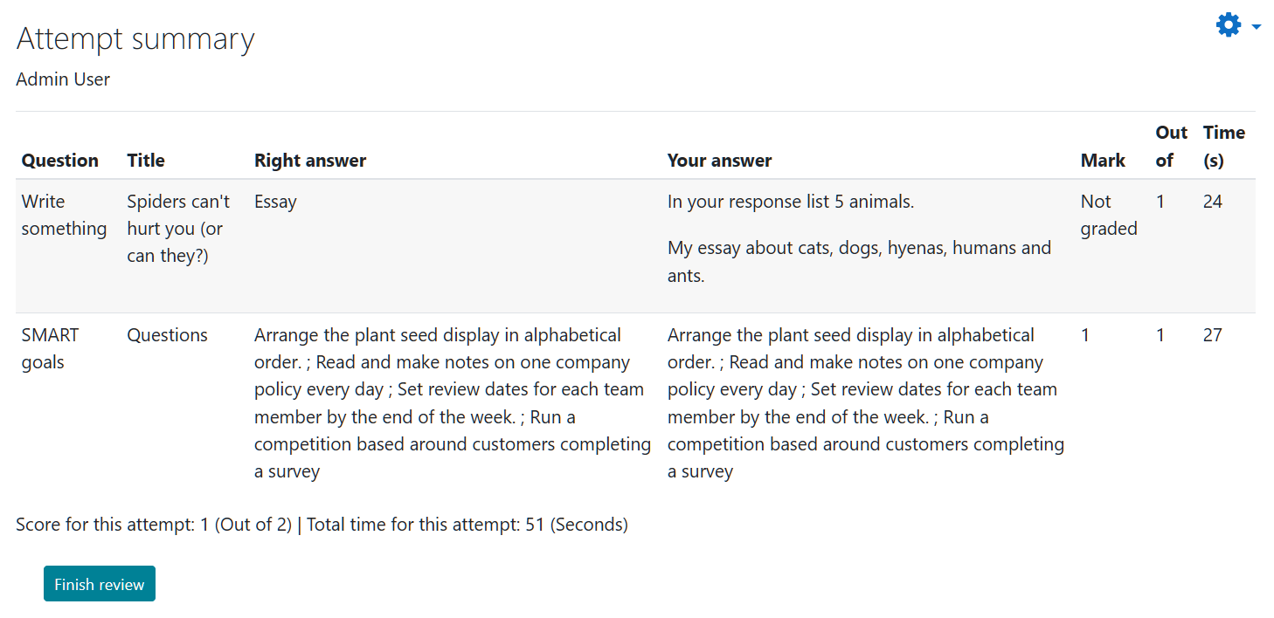

Essay Questions
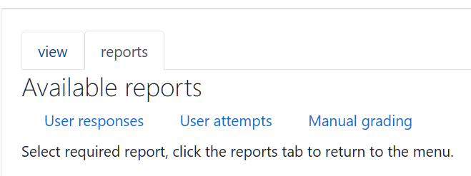
These are a special type of question that is created in the Question Bank and allows the user to write an extended piece of rich text, including media. It has to be marked manually by the teacher to receive a grade.
There is a Manual grading link under the reports tab (normally this won’t be visible to students).
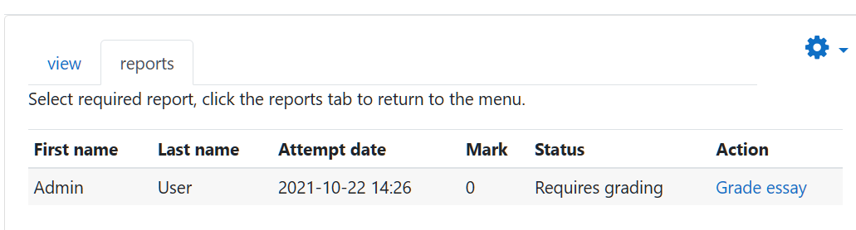
This link will show all essays in the Simple Lesson and provide a grading link.

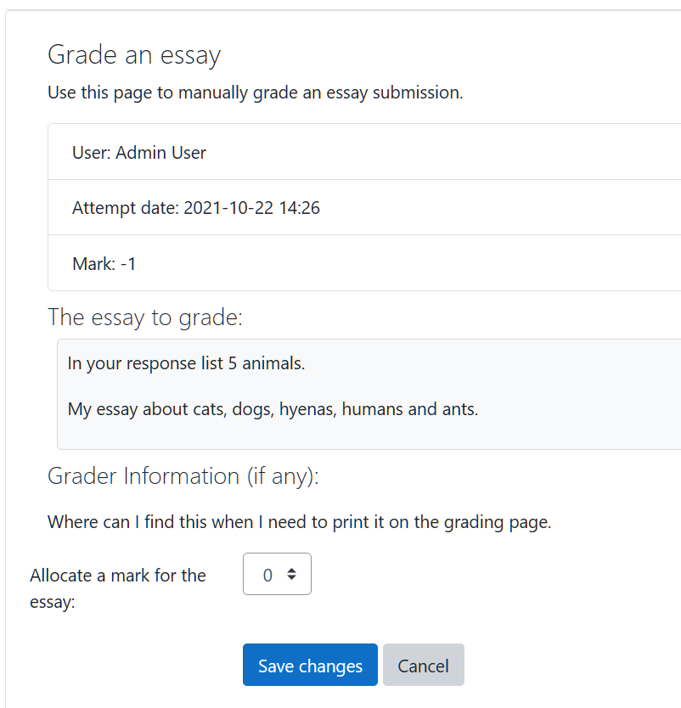
Clicking the link will allow a mark to be allocated for the essay question.

If the creator of the essay question has provided any information to assist in essay marking it will be displayed on this screen.

Reports
Answer reports and attempt reports are available and can be exported as a csv file if required (eg for use in a spreadsheet program).

User Report
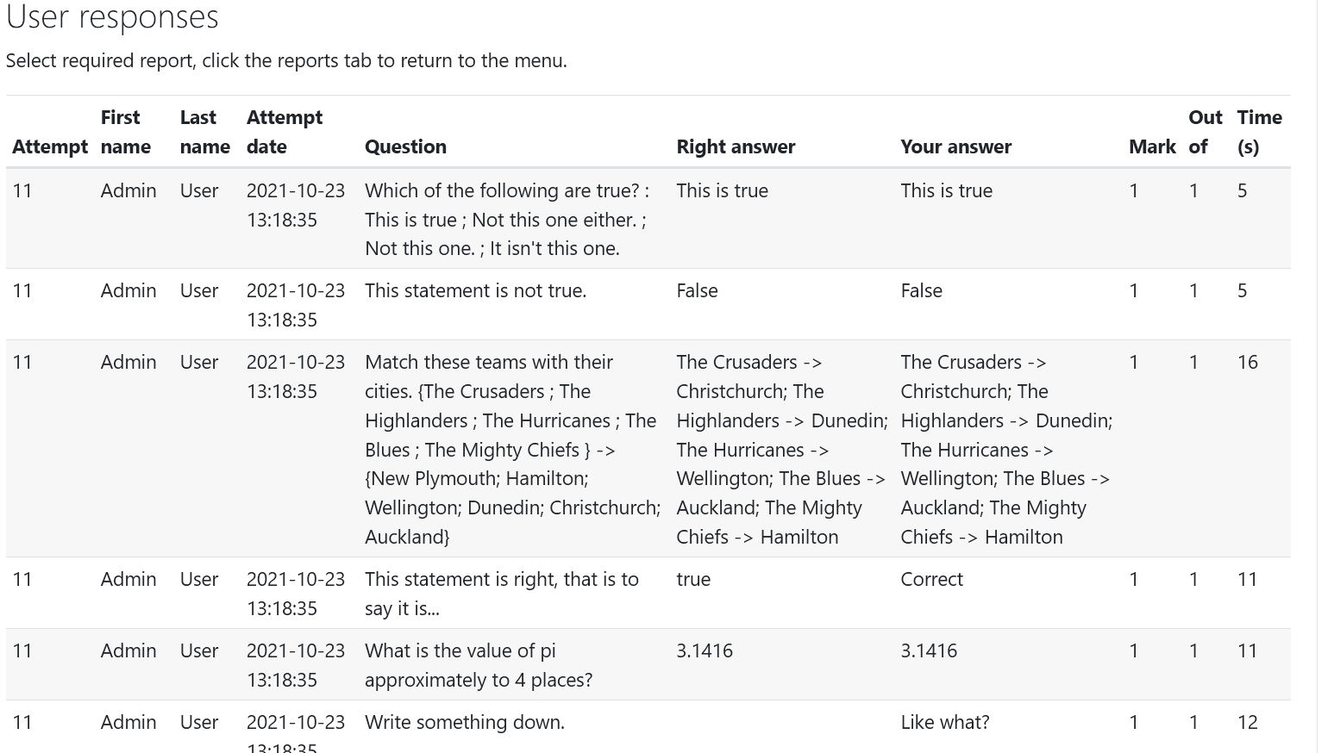

User Attempts
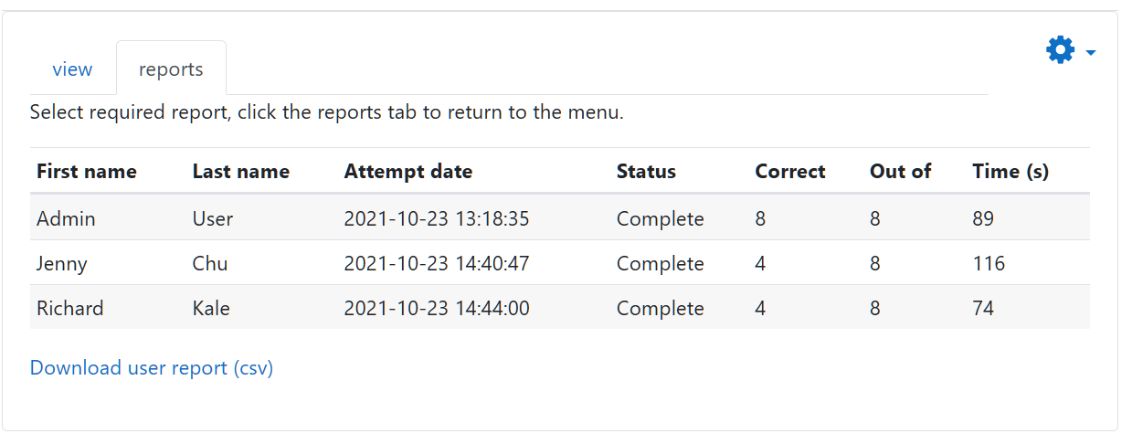

Attempts Management
You can also manage the attempts (to delete and allow a retry, for example):
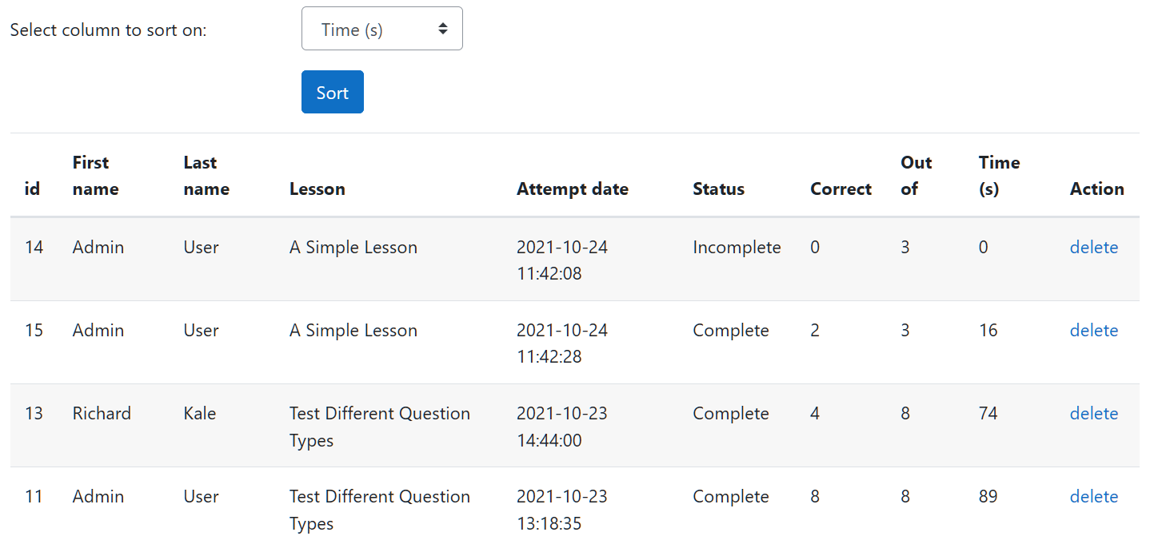
This report is a course-wide report showing all attempts at all instances of Simple lesson in a course. Attempts management is available from the module’s breadcrumbs (or activity settings in other themes).

Learning Strategies
Simple lesson allows a number of different strategies or uses in the classroom (or elsewhere). It is designed to be more of a formative tool than a summative one.

Presentation tool
You can use it simply as a slideshow or presentation to present multiple pages of multimedia information to the user. In this way it is similar to a book but without chapters and sub-chapters.

Pop quiz
When you don’t want to go to all the bother of designing a quiz, Simple lesson is a quick way to put together questions you have already created (of course you can also create questions from within Simple lesson as well).

Demonstration of learning
If you adjust the permissions for an instance of Simple Lesson you can allow students to create their own Simple lessons to demonstrate their knowledge of a subject and to test their colleagues as a fun activity.

Assessment of understanding
Because Simple lesson provides a number of statistics on student answers and attempts, downloadable to csv, you can gain some insights into student learning as you would do for a quiz. One advantage might be that you can create content pages more easily in Simple lesson than you can in a quiz and you can order them very quickly with the autosequencing feature.

Troubleshooting
The most common complaint in version 1 has been the “missing” navigation controls. These will not display during an attempt when Allow incomplete is unchecked and the question hasn’t yet been answered/completed.
Please make comments and observations at GitHub or use the support forum on the plugin page.
- Github: https://github.com/richardjonesnz/moodle-mod_simplelesson
- Moodle Plugins Directory: https://moodle.org/plugins/mod_simplelesson
Demonstration website: https://open-learning.co.nz/ (log in to Open Courses as a guest to try it).

Thank you
Thank you for your interest in Simple Lesson.
Richard Jones
Pirongia, New Zealand
November 2021
richardnz@outlook.com

